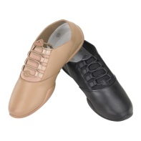
My student ____________________________ will need the following items: (Please place a check mark in the spaces that apply and total your checks.)
GUARD
Shoes $25.95 SIZE: ______
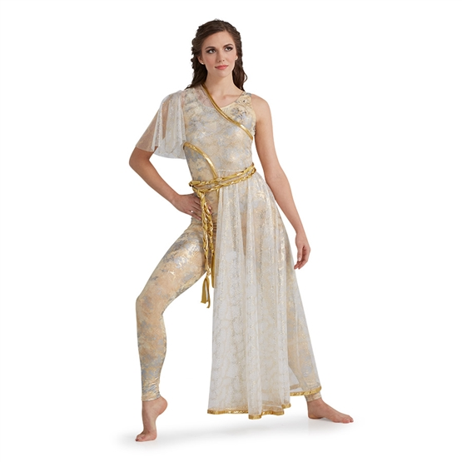
Uniform $158.85

Uniform COST TOTAL:
158.85
+25.95
$184.80
+ 7.62 S&H
TOTAL $192.42
DUE in FULL August 13 , 2018
Make checks out to: Tunstall Music Boosters. Please include your phone number on the check!

